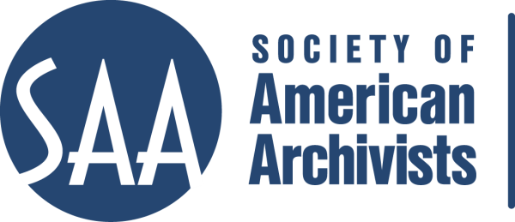
CE Workshop Evaluation Form
Arrangement and Description Track

Workshop Evaluation Form:

Title | Fundamentals of Encoded Archival Description and XSLT Stylesheets
Reviewer: | James Roth
Directions:
- Quantitative: Each item below begins with a bolded statement. Score each with a 1-5 ranking to indicate your assessment of the veracity of that statement based on your review of workshop overviews/agendas, evaluations, and other materials.
- Qualitative: In the comments section for each item below, please respond to the additional questions posed and any related issues that this workshop raises for you.
- Provide any additional assessments or comments not relevant to one of the specific, numbered areas in the space provided following the table.

Please place an “x” in the appropriate column, use 1=low, undesirable, to 5=high, excellent. |  |  | 1 | 2 | 3 | 4 | 5
1. Does the content appeal to its specified audience? Does it indicate specific categories of archivists and/or levels of expertise to assist potential participants in determining the workshop's relevance for them?  Comments: Yes, this has high appeal. No it does not specify categories of archivists and/or levels of expertise, but it does specify administrators. This is for the more advanced archivist rather than the beginning archivist. |  |  |  |  |  |  | X
2. To what extent does the subject matter reflect current archival practices and theory commonly accepted in the profession?  Comments: This reflects current/future archival practices and theory. EAD has become the standard for online finding aids. These two instructors have set the standard. |  |  |  |  |  |  | X
3.. How relevant/appropriate are the teaching and delivery methodologies (lecture, video, PowerPoint, exercises, film, audiotape, discussion, simulation, case study, opportunities for in-course feedback, etc.) to the articulated goals and objectives, and to the content?"  Comments: Lecture, and discussion/hands-on exercises. Very relevant/appropriate, however I wonder that there is no PowerPoint. Was that left out of the review materials? The handout is exceptional in scope, detail and level of granularity. |  |  |  |  |  |  | X
4. How workable is the time line or agenda for the course? Is there sufficient detail to indicate how the workshop will evolve? Does it allow sufficient time for active engagement between course participants and the instructor(s)?  Comments: This seems perfect for a 2 day workshop. |  |  |  |  |  |  | X
5. To what degree does the list of assigned readings support the content of the proposal?  Comments: No real assigned readings except the standard itself. There are several supporting websites that are highlighted in the handout. There certainly is enough written now about EAD that they could include a list of readings. |  |  |  |  |  | X
6. Does the presentation support the Learning Outcomes in the descriptions?  Comments: Needs to have learning outcomes in the description—unless you mean Workshop Objective. Those it meets. |  |  |  |  |  | X
 | A&D Track Considerations
 | 1.Does this content bridge, enhance, and/or build on other workshops (If so, please name) | This is a more advanced workshop for EAD, but it is listed as Fundamental in the title. I think because the second day is about Stylesheets, this should have a prerequisite.
 | 2.Does this build on other workshops not on the list? | Could build on “Beginners Guide to Metadata” and “Describing Archives: A Content Standard”
 | 3 Should this be part of the A&D Track? | Yes, I believe it should be a part of the A&D track.
 | 4.Where would this workshop fall in the sequence of an A&D track? | It is a Standards-based workshop, so it should fall somewhere between the truly fundamental A+D courses and the next level up.
 | Why? | Audience needs to have intermediate level of knowledge. Should Standards-based workshops be Tactical and Strategic, or Fundamental?
 | 5. What tier does this workshop fall in? (See attached tiers) | Either under Tactical and Strategic or Tools and Services.
 | 6. Target Audience | Practicing Archivists who are considering using EAD.
 | 7. Is the suggested prior “experience/knowledge” appropriate? | I couldn’t find “experience/knowledge” listed. Needs to include.
 | 8. Learning Outcomes:  Are they appropriate and/or relevant? | Not listed. Don’t know. Need to develop.
 | 9. What should they be?  Please list learning outcomes. | Stated as Workshop Objectives:  - Recognize the components of the eXtensible Markup Language (XML) technical standard;  - Apply the key elements of EAD, encoding a finding aid using XML editing software; and  - Grasp the fundamentals of the eXtensible Stylesheet (XSLT) programming language sufficiently to modify existing stylesheets or create a basic one from scratch to generate a Web-ready EAD document.
 | 10. Can you make suggestions for competencies this workshop would fulfill? | ?
 | 11. Would parts of the content lend themselves to a different format? NO | Check one: Webinar: - 30 minute - 90minute In person: - 1/2 day - 1 day - 2 day
 | 12. Which parts? | N/A
 | 13. Does it lend itself to repurposing as an audio CD? | No
 | Which parts? | N/A

Other comments:
This seems like it just needs to be updated. Tweak the information already existing to fit the new format (Learning Outcomes versus Workshop Objectives). This is a Fundamental course, but I think it should either be Tactical and Strategic or Tools and Services because of the Stylesheets and the need to utilize an editor.

